Biology Fall Semester Final Review Guide

Helpful Information:
- Test is about 75 multiple choice questions. Be ready with pencil on the day of the test.
- Topics that will be covered: Scientific Method (Chapter 1), Cell structure (Chapter 3), Cellular transport (Chapter 4), Water (Chapter 2), Mitosis (Chapter 6), DNA (Chapter 9), Protein Synthesis (Chapter 10), Meiosis (Chapter 7), Genetics (Chapter 8)
- Study ALL lab book pages and review ALL handouts/labs!
- You will be allowed to have one index card for use on your final exam. It must be no larger than a 4”x6” index card. It can have writing on both sides. It will be collected at the end of the exam.
- Recommended vocabulary is below. You DO NOT need to define all vocabulary words as part of this assignment but it is highly recommended you define these and come up with an example.

Scientific Method
Qualitative
Quantitative
Inference
Observation
Hypothesis
Prediction
Biology
Metabolism
Homeostasis
Heredity
Mutation

Cells
cell theory
prokaryote
eukaryote
phospholipids
lipid bilayer

Cell Transport
passive transport
concentration gradient
equilibrium
diffusion
osmosis
hypertonic
hypotonic
isotonic
ion channel
carrier protein
facilitated diffusion
active transport
sodium-potassium pump
endocytosis
exocytosis

Water
Covalent bond
Molecule
Ionic bond
Proteins
Amino acid
Enzymes
Nucleic acid

Mitosis
Binary fission
Chromosome
Somatic cells
G1 phase
S phase
G2 phase
Diploid cells
Haploid cells
Sister chromatid
Centromere
Chromatin
Histones
Interphase
Prophase
Metaphase
Anaphase
Telophase
Cytokinesis

Meiosis
asexual reproduction
clone
crossing-over
synapsis

DNA
Nucleotide
Chargaff’s rule
Double helix
DNA replication
Replication fork
Helicase
DNA polymerase
Ligase
Deoxyribose

RNA & Protein Synthesis
protein
amino acid
uracil
transcription
translation
RNA polymerase
messenger RNA
codon
transfer RNA
anticodon
ribosomal RNA

Genetics
allele
codominance
dominant
F1 generation
F2 generation
genotype
heterozygous
homologous chromosome
homozygous
incomplete dominance
law of independent assortment
law of segregation
monohybrid cross
P generation
pedigree
phenotype
polygenic inheritance
punnett square
recessive
sex-linked gene

Scientific Method
A scientist named Dr. Smartee, wondered why his two favorite fish, Flotsem and Jetsem were not growing at the same rate. Flotsem, a male, was growing at a faster rate than Jetsem, also a male. He bought the fish at the same time and the fish salesman assured him that they were the same age. He thought that maybe one fish was eating all the food during feeding time. The scientist decided to do an experiment. He separated the fish into two different tanks and fed them the same amount of food for two weeks, made sure they had the same amount of light, and kept the solute levels the same. After two weeks he weighed the fish and was amazed by the results. Flotsem’s weight had increased by 1 gram, and Jetsem’s weight increased by 4 grams.

- What was the independent variable in the above scenario?

- What was the dependent variable in the above scenario?

- What are two controlled variables that were identified in the above scenario?

- What were the results of this scenario?

- Did the results support Dr. Smartee’s hypothesis?

- Could Dr. Smartee conclude that Flotsem was stealing Jetsem’s food or is another explanation possible for the results?

- Graph the Result
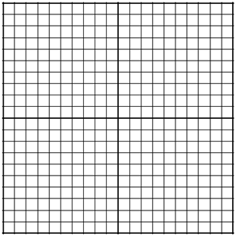

Cells
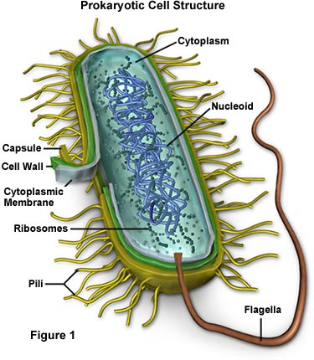
- Label the organelles on the animal, plant, and bacterial cell.

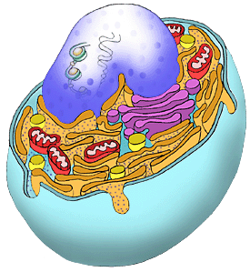
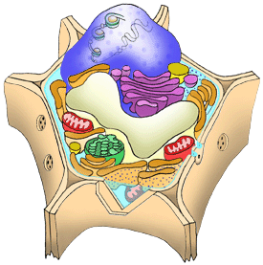

- What is a prokaryote? Give an example.

- What is a eukaryote? Give an example.

- List 2 differences between prokaryotes and eukaryotes?

- What cells were most likely the first cells on Earth? (Prokaryotes or Eukaryotes?)

- List three differences between plant and animal cells?

- What are the three parts of the Cell Theory?

- What scientist first observed cork cells under a microscope? _________________

- Please put the following terms in correct order of the level of organization. (tissues, cells, organelles, organism, organ system, organ)

- Why do we call the cell membrane semi-permeable?

- What organic molecules are the main component of the cell membrane?

- In the table below list the function of each of the organelles.
Organelle |  | Function = WHAT IT DOES!
Cell membrane
Cytoplasm
Nucleus
Nucleolus
Mitochondria
Ribosomes
Endoplasmic Reticulum
Golgi Apparatus
Lysosomes
Cytoskeleton
Cilia
Cell wall
Vacuole
Chloroplast

Cellular Transport
- What is homeostasis?

- Define: hypertonic, hypotonic, isotonic.

- Complete the following table.
Type of solution | Where is solute concentration the highest (inside cell or outside cell) | Will water move in or out of cell? | Will the cell swell, shrink, or stay the same size?
Hypertonic
Hypotonic
Isotonic

- How are active transport and passive transport different?

- List and describe the types of passive transport.

- List and describe the types of active transport.

- What is the difference between osmosis and diffusion?

- Food coloring will diffuse through water until it reaches? ___________________

Water
- What is cohesion?

- What is adhesion?

- What is specific heat?

- Water has a HIGH specific heat. Why is this property of water important to life?

- What is capillary action?

- How do plants use capillary action?

Mitosis/ Meiosis
- What is the correct order of the cell cycle? Put the terms in the correct order: (metaphase, telophase, prophase, cytokinesis, interphase, anaphase,)

- Why is the process of mitosis important for an organism? (give me three reasons)

- How many cells are produced during mitosis? Are the resulting daughter cells genetically identical or different from the parent (original) cell?

- Are diploid or haploid cells produced in the process of mitosis?_______________

- Why is the process of meiosis important for an organism?

- What is crossing over and why is it important?

- When does crossing over occur?

- How many cells are produced during meiosis? Are the resulting daughter cells genetically identical or different to the parent (original) cell?
- Are diploid or haploid cells produced in the process of meiosis? _______________

- If an organism has a haploid number of 8, how many chromosomes would it have in its diploid cells?

- What is the difference between our Somatic Cells and our Gamete Cells? Use correct biology terms!!!

- In humans, how many chromosomes does each of the daughter cells have after meiosis?

- Draw and Label all stages of Mitosis/Meiosis.
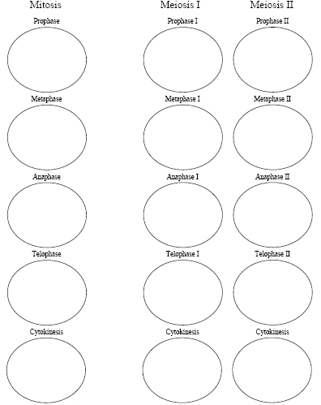

Molecular Genetics (DNA, RNA, proteins)
- What is a chromosome?

- What is a Chromatid?

- What is Chromatin? What protein is important in forming Chromatin?

- What is a gene?

- What do genes code for?

- DNA is made up of what molecule? (Hint: this molecule has 3 parts) Draw it!!!!!

- Use Chargaff rules to solve this problem. An organism’s DNA is made up of 30% Adenine nucleotides. The rest = _______%Thymine _______%Guanine ______%Cytosine

- What is the structure of DNA? Draw a simple picture to show DNA shape.

- What part of the DNA molecule splits during replication?

- What enzyme splits apart the two DNA strands during DNA replication?

- What are 3 differences between DNA and RNA?

- What is the central dogma of biology?

- Transcribe the mRNA from the following piece of DNA:
T-A-C-C-G-A-A-T-T-A-C-T-A-G-T-A-C-G

- Translate the mRNA that was produced in the previous problem into an amino acid chain.

- Describe the process of Protein Synthesis.
  - What is transcription? Where does it occur in the cell?

  - What is translation? Where does it occur in the cell?

- What are the building blocks of protein?

- What organic molecules are responsible for speeding up reaction in living systems?

Genetics
- Who is considered to be the “father” of genetics?

- What is an allele?

- Define homozygous and heterozygous. Give an example of each.

- Define genotype and phenotype. Give an example of each.

- If Sally has dimples and is heterozygous, what can you conclude about dimples?

- What is Incomplete dominance? Give an example.

- What is Codominance? Give an example.

- If an apple tree has a genotype of RRYy, what are the possible gametes that plant may produce?

- Sex linked genes tend to be carried on what sex chromosome?

- What can you learn from a karyotype?

- What sex chromosomes does a male carry? Female?

- Everyone in Squidward’s family has blue skin, which is the dominant trait. Squidward is heterozygous for his blue skin. His wife has green skin.
  - Create a punnet square to show the possible genotypes of their children.

  - What are the possible genotypes?

  - What are the possible phenotypes?

  - What are the chances (percent) of a child with blue skin?

  - What are the chances (percent) of a child with green skin?

  - Give the genotypic and phenotypic ratios.

- Below is a pedigree for an inherited lung disease. Add the roman numerals for generations. Provide the genotypes of each of the individuals marked with lower case letters.
